TECH SAKSHAM

CASE STUDY REPORT

DATA ANALYTICS WITH POWER BI

“ANALYSIS OF COMMERCIAL ELECTRICITY CONSUMPTION IN INDIAN STATES”

SRI PARAMAKALYANI COLLEGE, ALWARKURICHI

|  |  |
| --- | --- |
| NM ID | NAME |
| CFA637A8928F0919C074479E78B03B86 | P. Durga Devi |

|  |  |
| --- | --- |
| TRAINEE NAME | M. UMAMAHESHWARI |
| MASTER TRAINEE | M. UMA MAHESHWARI |

ABSTRACT

This paper focuses on using big data analytics to analyse the electricity consumption patterns of 500 consumers (residential) in a particular area over 24 months. The analysis was used to create visualization and graphs that helped to identify the consumption patterns of individual users as well as the overall trends in the area. Using the Power BI tool, a dashboard is created to showcase the results. The dashboard provides valuable information such as the top 5 consumers and average consumption values by users. This information can be used by utility companies to identify areas where consumption is high and to develop strategies to reduce overall electricity consumption. This study demonstrates the value of big data analytics in understanding complex patterns and identifying opportunities for energy savings.

|  |  |  |
| --- | --- | --- |
| S.NO. | TABLE OF CONTENTS | PAGE NO. |
| 1 | Chapter 1: Introduction | 3 |
| 2 | Chapter 2: Services and Tools Required | 7 |
| 3 | Chapter 3 : Project Architecture | 9 |
| 4 | Chapter 4: Modelling And Result | 11 |
| 5 | Conclusion | 20 |
| 6 | Future Scope | 21 |
| 7 | References | 22 |
| 8 | Links | 23 |

**CHAPTER 1**

**INTRODUCTION**

* 1. PROBLEM STATEMENT

Currently, electricity is used in every home for various task, including watching television, charging smart phones, using an electric light bulb, even now electric bikes and for other purposes. Electricity has became essential part of our day-to-day life. It powers our homes, businesses, and industries, and has enabled us to achieve unprecedented levels of comfort, convenience, and productivity. However, this growing dependence on electricity has led to a significant increase in its consumption, placing enormous pressure on energy resources and the environment. In recent years, there has been a noticeable rise in electricity consumption, driven by the increasing use of electronic devices, appliances, and industrial machinery. This trend is expected to continue in the upcoming years, with the growth of emerging markets and the adoption of new technologies, such as electric vehicles and renewable energy system. To meet the growing electricity demand, utility companies are exploring new ways to optimize energy production and distribution, while minimizing waste and reducing emissions.

* 1. Proposed Solution

To achieve this goal, big data analytics has emerged as a promising tool for analysing electricity consumption patterns and identifying opportunities for energy saving. By analysing large volumes of data generated by smart meters and other monitoring devices, utility companies can gain insights into the behaviour of individual consumers, as well as the overall trends in consumption. This information can be used to develop targeted strategies for reducing energy use, promoting energy efficiency, and managing peak demand. The paper aims to present a study on the electricity consumption patterns of 500 residential consumers in a particular area over 24 months, using big data analytics. The data was obtained from the MSEB and analysed to identify trends in consumer behaviour.

1.3. Feature

* **Real-Time Analysis**: The dashboard will provide real-time analysis of electricity consumption data.
* **Customer Segmentation**: It will segment customers based on various parameters like dates, usage, latitude, longitude, etc.
* **Trend Analysis**: The dashboard will identify and display trends in electricity consumption.
* **Predictive Analysis**: It will use historical data to predict future electricity consumption.

**1.4. Advantages**

* **Data-Driven Decisions**: Government can make informed decisions based on real-time data analysis.
* **Improved Engagement**: Understanding electricity consumption and trends can help government engage with their consumption of electricity more effectively.
* **Increased Revenue**: By identifying consumption rate for wind energy and water energy, government can increase their revenue.

**1.5Scope**

The scope for consumption of electricity in India is immense, driven by factors such as population growth, urbanization, industrialization, and increasing adaption of electric appliances and technologies. With on going government initiatives to expand access to electricity and promotes renewable energy sources, the demand for electricity is expected to continue rising. Some studies use a top-down methodology for estimating electricity demand based on its relationship (regression equations or elasticity factors) with macroeconomics variables. However, this approach is limited with regards to addressing the transformational aspects of such relationship over a longer horizon, since electricity requirement is in effect obtained as either a second or third order effect from changes in macroeconomic factors. Hence, the role of choice and innovation in the technology-policy space needs to be factored in order to translate changes in macroeconomics variables into service demands and finally into electricity demand.

**CHAPTER 2**

**SERVICES AND TOOL REQUIRED**

**2.1 Services Used**

* **Data Collection and Storage Services**: Electricity consumption of Indian states is collected from various industrial sectors consuming the power and the energy production resources are also collected and stored in cloud.
* **Data Processing Services**: Services like Azure Stream Analytics or AWS Kinesis Data Analytics can be used to process the real-time data.
* **Machine Learning Services**: Azure Machine Learning or AWS Sage Maker can be used to build predictive models based on historical data.

**2.2 Tools and Software used**

**Tools**:

* **Power BI**: The main tool for this project is Power BI, which will be used to create interactive dashboards for real-time data visualization.
* **Power Query**: This is a data connection technology that enables you to discover, connect, combine, and refine data across a wide variety of sources.

**Software Requirements**:

* **Power BI Desktop**: This is a Windows application that you can use to create reports and publish them to Power BI.
* **Power BI Service**: This is an online SaaS (Software as a Service) service that you use to publish reports, create new dashboards, and share insights.
* **Power BI Mobile**: This is a mobile application that you can use to access your reports and dashboards on the go.

**CHAPTER 3**

**PROJECT ARCHITECTURE**

**3.1 Architecture**

**USER FRONTEND BACKEND**

|  |  |  |
| --- | --- | --- |
|  | **HTML 5** | **NODEJS 14.0**  **Database** |

Here’s a high-level architecture for the project:

1. **Data Collection**: Gather energy consumption data from various sources, such as smart meters, sensors, or utility builds. Ensure that data is accurate and covers a suitable timeframe for analysis.
2. **Data Storage**: Data storage is the retention of information using technology specifically developed to keep that data and have it as accessible as necessary.
3. **Data Processing**: It is a process of standardizing how an organization collects, stores, transforms, distributes, manages, and uses data. The end-goal of data architecture is to deliver relevant data so that stakeholders can leverage it to make strategic decisions and enhance business processes.
4. **Machine Learning**: Predictive models are built based on processed data using Azure Machine Learning or AWS Sage Maker. These models can help in predicting customer behaviour, detecting fraud, etc.
5. **Data Visualization**: The processed data and the results from the predictive models are visualized in real-time using Power BI. Power BI allows you to create interactive dashboards that can provide valuable insights into the data.
6. **Data Access**: The dashboards created in Power BI can be accessed through Power BI Desktop, Power BI Service (online), and Power BI Mobile.

This architecture provides a comprehensive solution for real-time analysis of bank customers. However, it’s important to note that the specific architecture may vary depending on the bank’s existing infrastructure, specific requirements, and budget. It’s also important to ensure that all tools and services comply with relevant data privacy and security regulations.

**CHAPTER 4**

**MODELLING AND RESULT**

**Manage relationship**

The “1 data” file will be used as the main connector as it contains most key identifier (Column 1) which can be used to relates the 4 data files together.

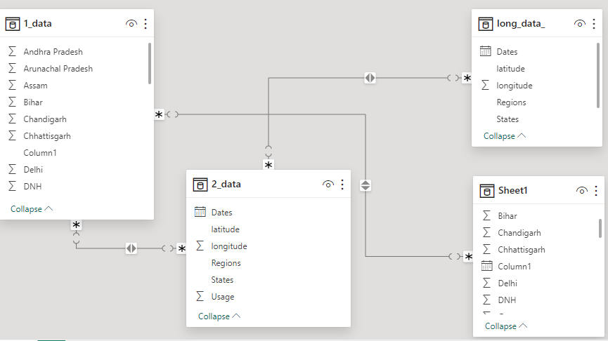

MANAGE RELATIONSHIPS

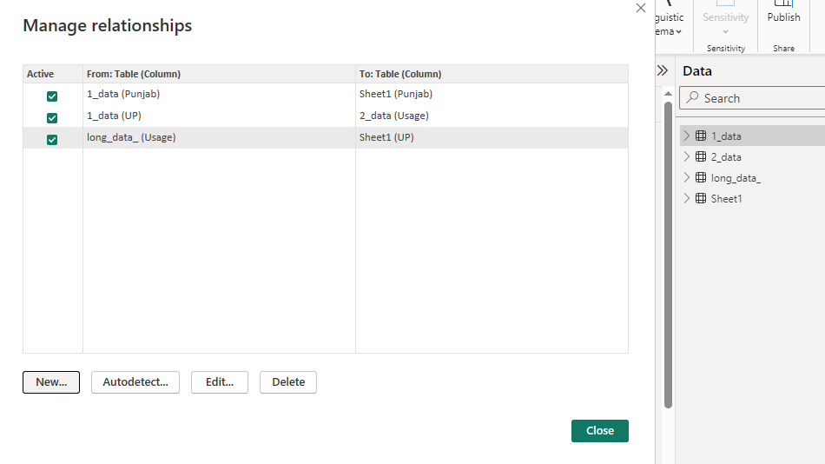

**EDIT RELATIONSHIP**

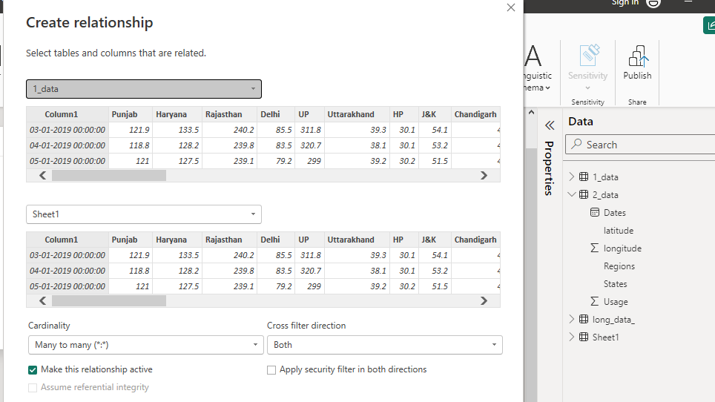

**MODELLING FOR DATE AND CONSUMPTION DATA**

Note that usage of consumption of electricity and Dates are there in the datasets by not sorted, so by using the ascending command, it is been sorted in ascending order.

The states are sorted in ascending order to find the highest consumption state and the usage of it.

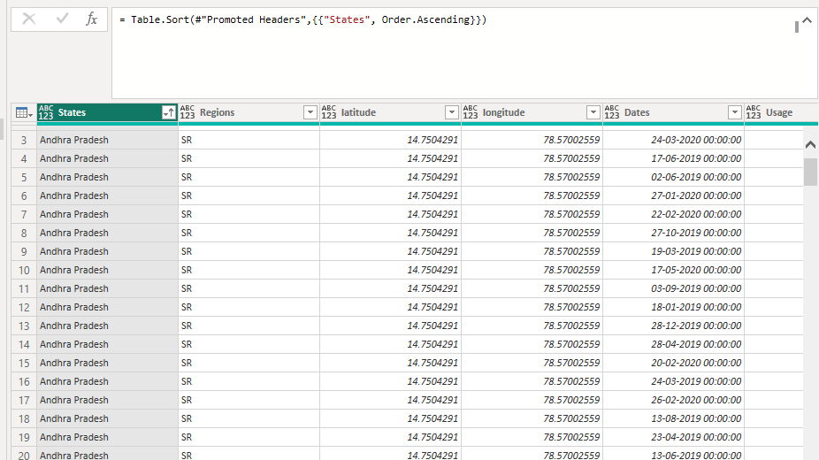

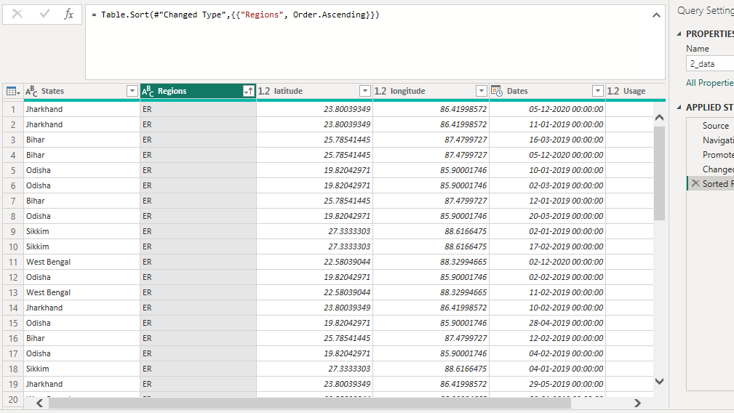

**REPLACING VALUES**

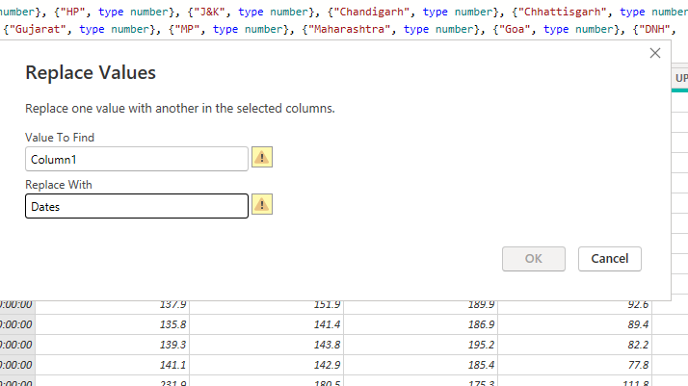

Duplicate the dates then split column using 00:00:00 as delimiter

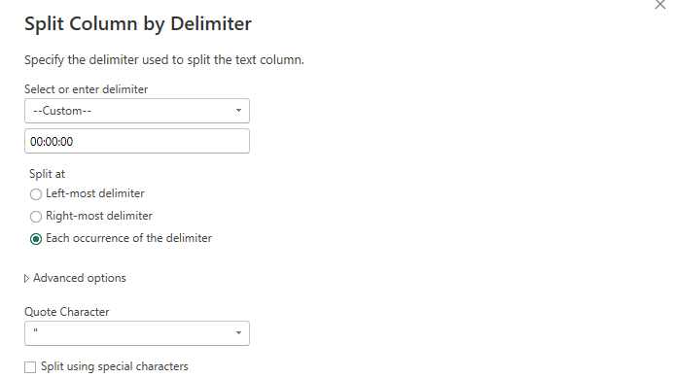

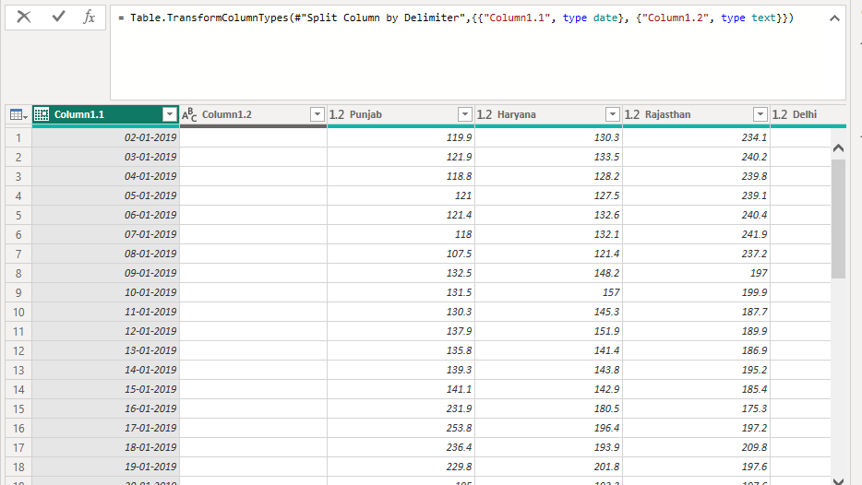

**GROUPING OF AGE BY RANGES**

As the States ranges from 0 to 29, we shall group them into different state range for easier profiling, we will group the states with the value of median.

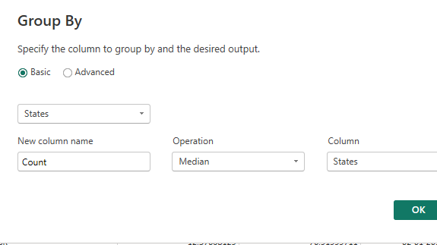

DASHBOARD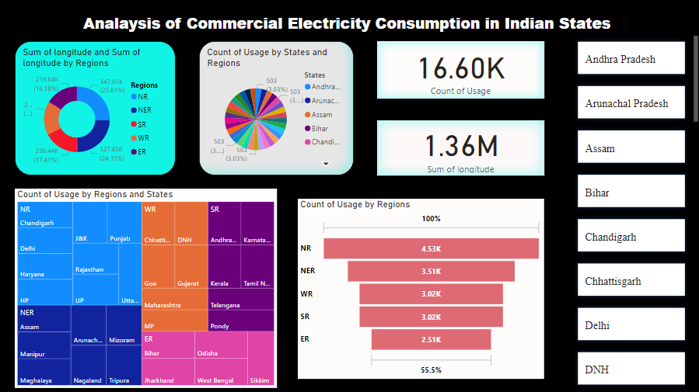

**CONCLUSION**

Finally, our research paper has successfully developed a consumption and prediction model that can be utilised to forecast electricity consumption for the next few months. We have also developed a dashboard using Power BI that can provide insights into the electricity consumption patterns, such as the top 5 consumers, sum values by user, splitting a columns using delimiter, values and counts by year and users. These insights can be leveraged to strategize policies and optimize energy usage in homes. Overall, our research provides a strong foundation for future studies on electricity consumption prediction and optimisation.

**FUTURE SCOPE**

To meet growing demand, the power sector must undergo continuous evolution. Projections for capacity addition consider factors such as the expected growth in demand, technological advancements, and the need for a diversified energy mix. As per the latest projections, India aims to add 150 GW of new capacity by 2030. The integration of IOT devices, advanced metering infrastructure, and AI will optimize electricity distribution, improve reliability, and enable demand-response programs. Overall, the future of electricity consumption will be characterised by sustainability, efficiency, and technological innovation as societies strive to meet growing energy needs while reducing environmental impact.

**REFERENCE**

<https://m.economictimes.com/industry/energy/power/indias-power-consumption-grows-nearly-8-pc-to-847-billion-units-in-first-half-of-fy24/articleshow/104254849.cms>

<https://www.youtube.com/live/kbe61N-qQ-s?si=yDuEQ1chLVG06_uF>

**LINKS**

[**https://github.com/Sankavi21231/Consumption-of-electricity-**](https://github.com/Sankavi21231/Consumption-of-electricity-)